Assignment B Quinty van Dijk

# Problem 1

The created trajectory of q1 is shown in figure 1

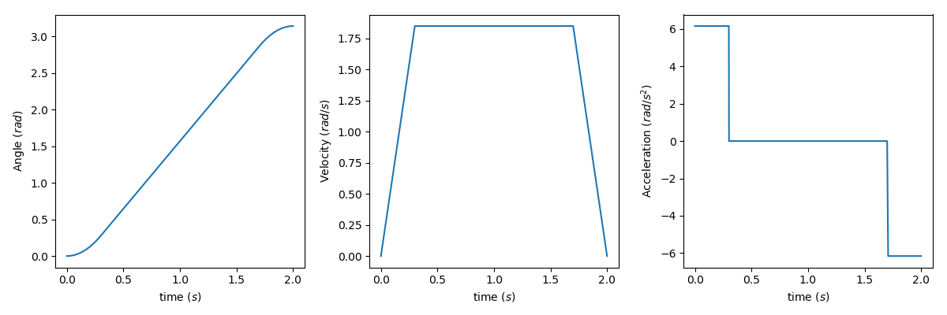

Figure 1 Trajectory of q1

The created trajectory of q2 is shown in figure 2. Maximum acceleration is a = (qf - q0)/(ts**2) = 1.57 m/s2

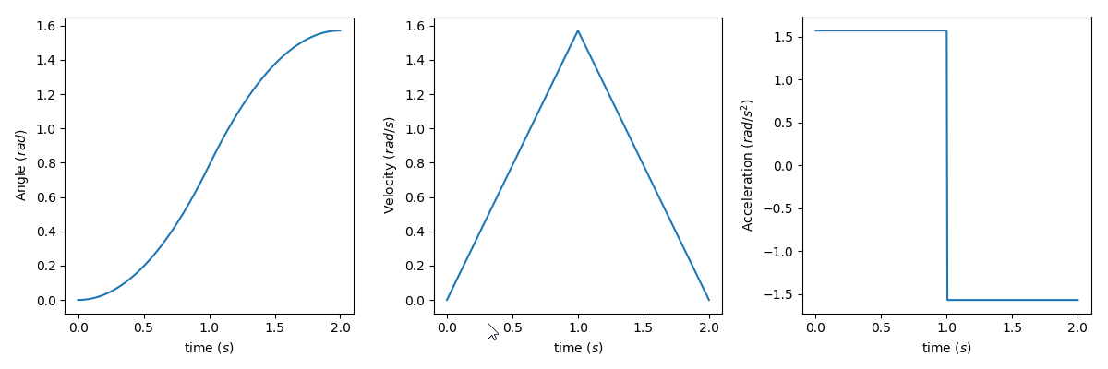

Figure 2 Trajectory of q2

# Problem 2

1. Angle 2 retracts inwards so that angle 1 can moves up. When there is enough space for angle 2 to “extent” again it does.
2. See figure 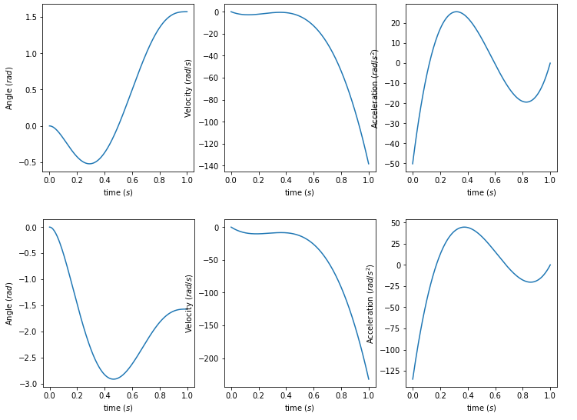

Figure 3 trajectories of q1 (above) and q2 (below)

1. The speed and acceleration graph look very familiar, but start and end with different values

Table 1 PD values

# Problem 3

|  |  |
| --- | --- |
| Kp | Kd |
| 16 | 7 |
| 9 | 9 |
| 1200 | 117 |

1. Gotten values for Kp and Kd are shown in table 1
2. 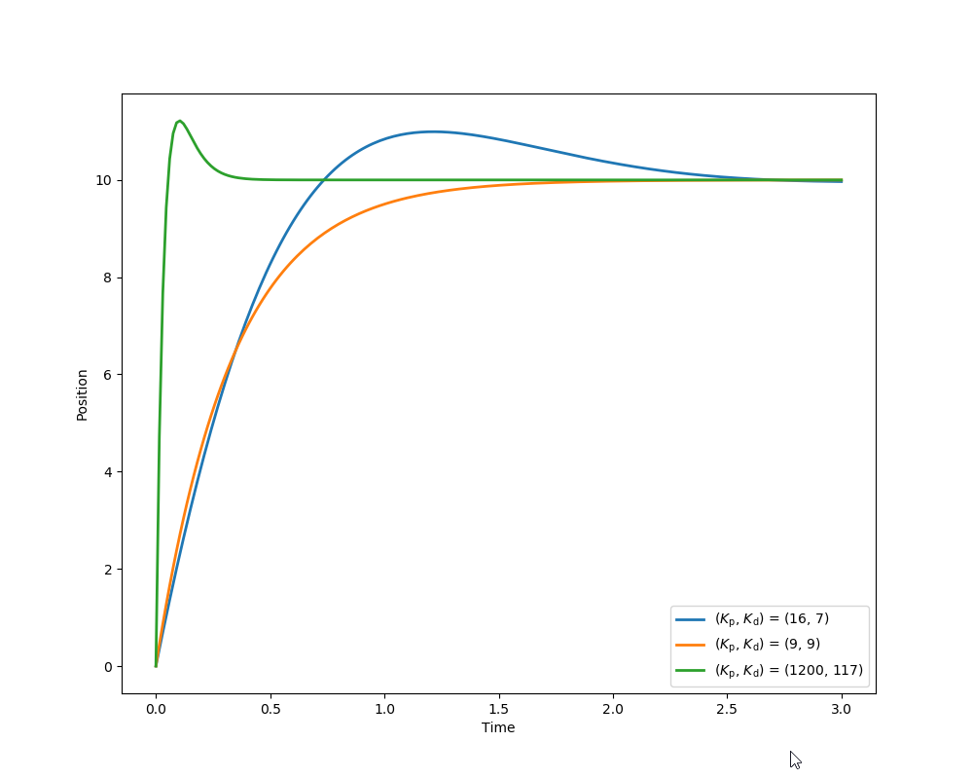The last PD controller responses quick. The second one has no overshoot. The first one slowly gets to the set point. See figure 4 for the plots

Figure 4 Response of PD-controllers

1. 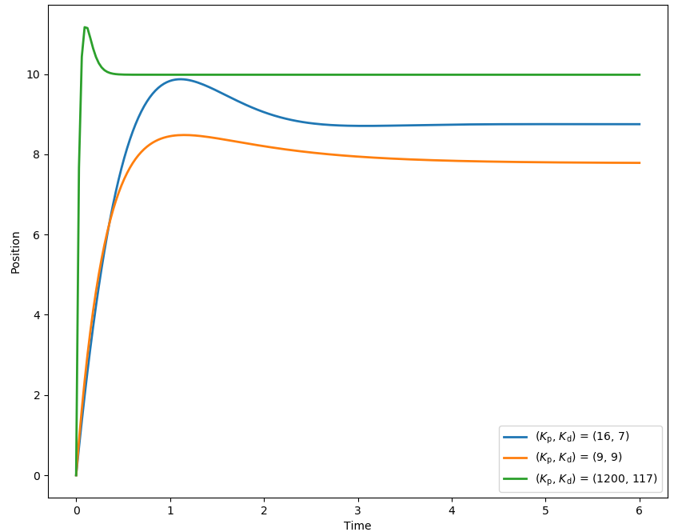The results of the PD controllers with presence of a constant disturbance is shown in figure 5

Figure 5 PD-controllers with disturbance

1. Ess=- D/Kp  
   -20/16 = -1.25  
   -20/9 = -2.22  
   -20/1200=-0.016
2. 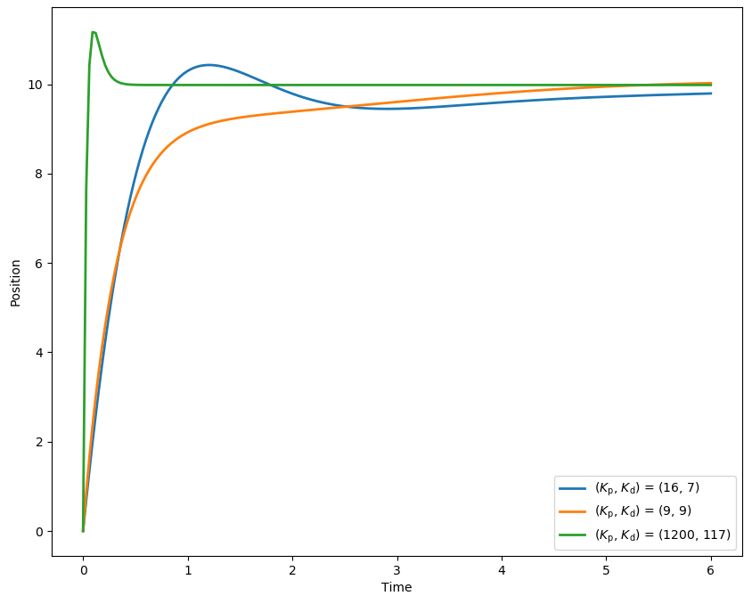Made the PD controller a PID controller with Ki = 4. This removes the disturbance over time. See figure 6.

# Problem 4

When there is no disturbance the Feedforward controller aren’t plotted because they would be the same as the reference signal. Values for PID controller are: 16, 7, 4 respectively. Reference is 5 when constant, 5/s when ramp and (5*2)/(s**2) when polynomial. Disturbance is 10 when constant and 10/s when ramp.

## constant reference, no disturbance

PID controller is slower to get to the reference. 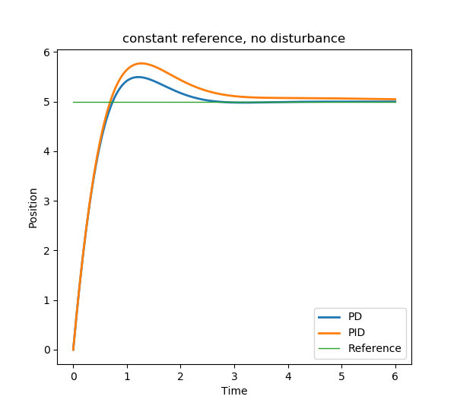

## constant reference, constant disturbance

Both PD controllers have a offset on the end, as expected. Both PID will get to the reference signal, the feedforward one has a undershot because of the disturbance as expected)

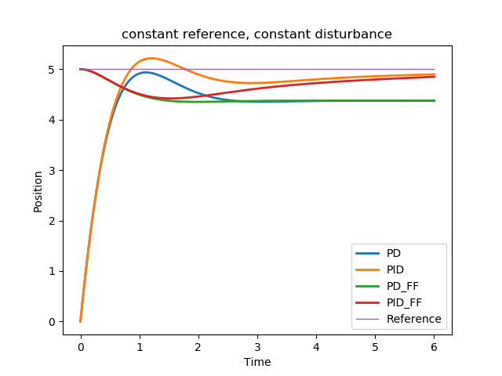

## constant reference, ramp disturbance

Controllers react to slow to the ramp disturbance to get to the reference.

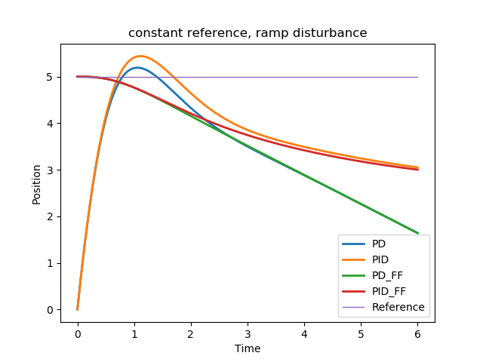

## ramp reference, no disturbance

PID controller slowly makes up for the difference between output and reference.

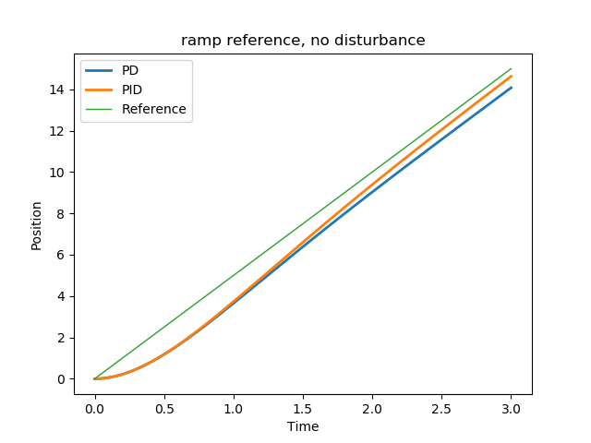

## ramp reference, constant disturbance

Again both PID controllers will get to the reference signal. 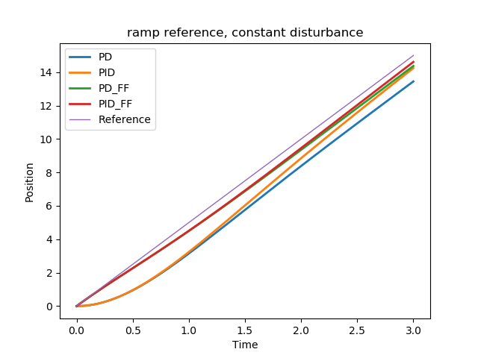

## second-order polynomial reference signal, no disturbance

Same situation as the ramp with no disturbance, the PID controller gets closer the the reference signal.

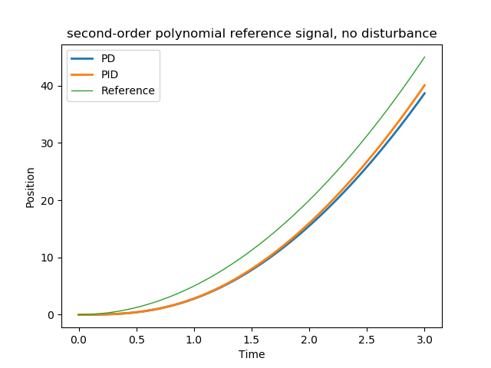

## second-order polynomial reference signal, constant disturbance

Both feedforward controllers seem to follow the reference signal very well.

